- When Would You Prefer Powerline Networking?
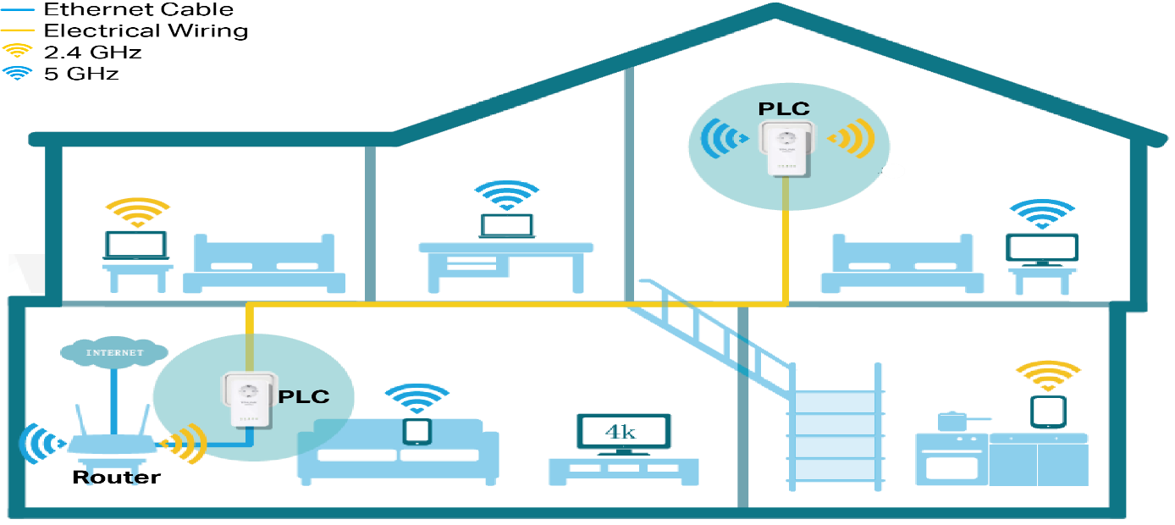

- When Wi-Fi signals are weak or unstable in certain rooms.
- In homes with thick walls that block wireless signals.
- When running Ethernet cables is difficult or messy.
- For extending internet to distant rooms using existing wiring.
- When you need a stable connection for gaming or streaming.
- In multi-floor buildings where Wi-Fi coverage is poor.
- When you want a simple plug-and-play networking solution.
- For connecting smart TVs, desktops, or gaming consoles.
- When you need better performance than Wi-Fi in some areas.
- In rental homes where drilling or wiring is not allowed.
- When setting up a quick and cost-effective network extension.
- When you want more reliable connectivity than wireless interference-prone networks.
- Why is Fiber Preferred for Long-Distance Links?
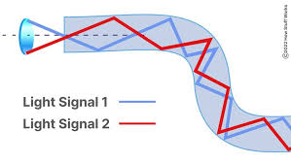

- Fiber transmits data using light, which travels very fast.
- Supports extremely high data speeds (high bandwidth).
- Has very low signal loss over long distances.
- Can carry data over kilometers without repeaters.
- Immune to electromagnetic interference.
- Provides more reliable and stable communication.
- Offers better security (harder to tap signals).
- Lightweight and thinner compared to copper cables.
- Supports large-scale networks like internet backbones.
- Reduces latency in long-distance communication.
- Requires less maintenance over time.
- Ideal for high-performance applications like data centers and telecom.

